**Report for compiling the Miracl Library (.lib) file:**

The program is compiled in windows 10 using Visual Studio 2012.

* We will compile the Miracl library. We will use the library in our programs to build cryptographic schemes like CP-ABE. To compile the library follow the following steps:
* First of all download the Miracl distribution. To download Miracl distribution go to the GitHub link given below:

[For Link Click Here](https://github.com/miracl/MIRACL)

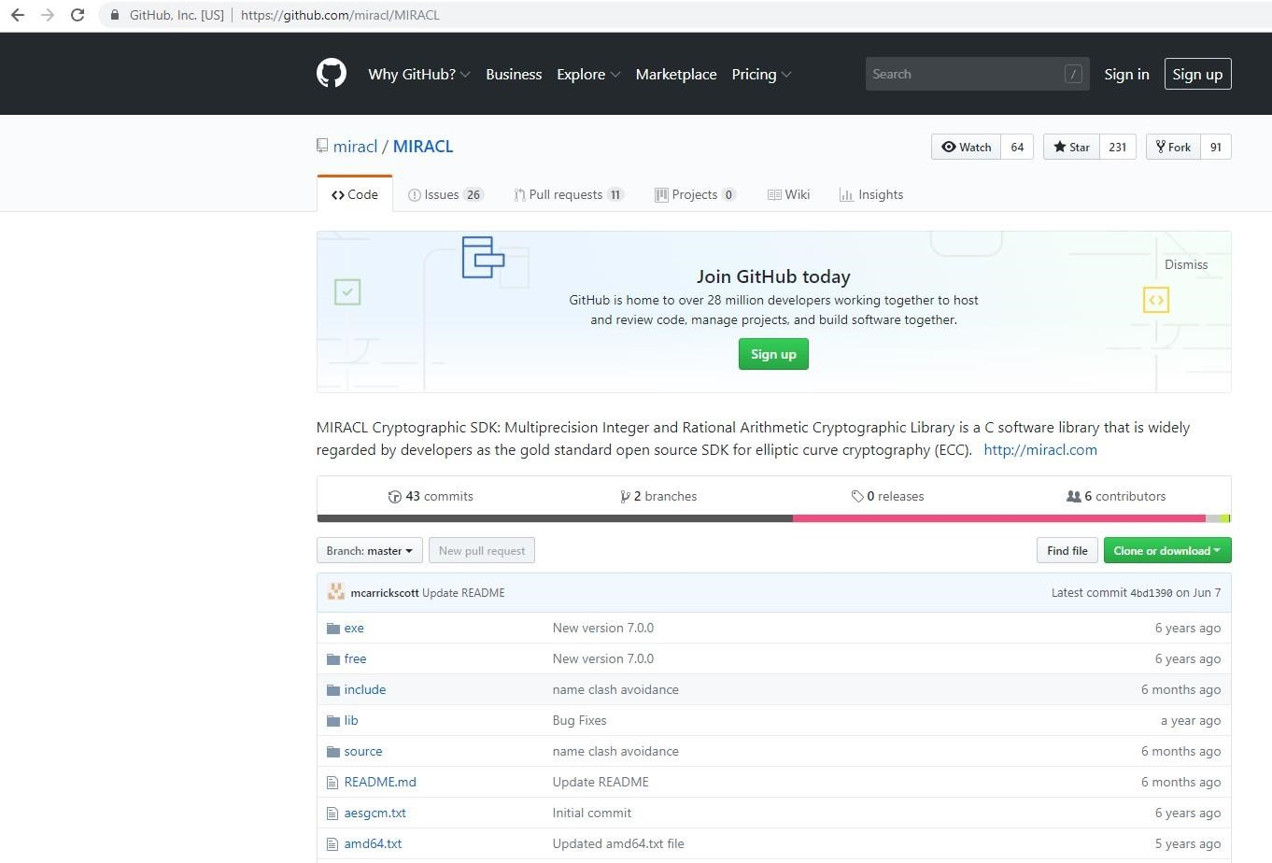

* Now Click on “Clone or download” as shown in figure.

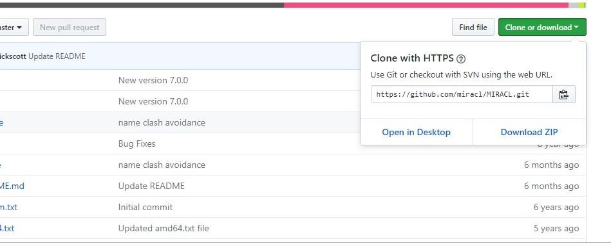

* Click on “Download Zip”

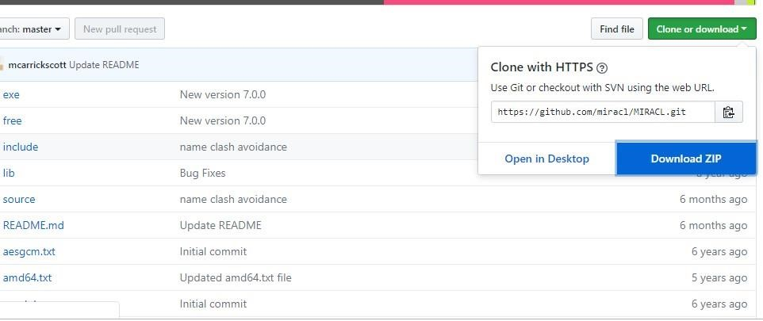

* Open the downloaded “MIRACL-master.zip file ” and extract the Miracl-master folder. As shown in figure

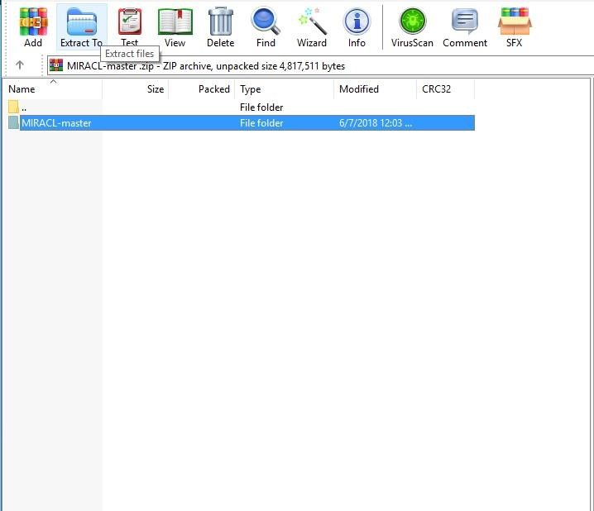

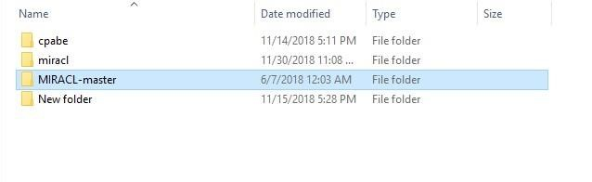

* Now we will start compiling the miracl library (miracl.lib).

1. Select New Project, Console Application

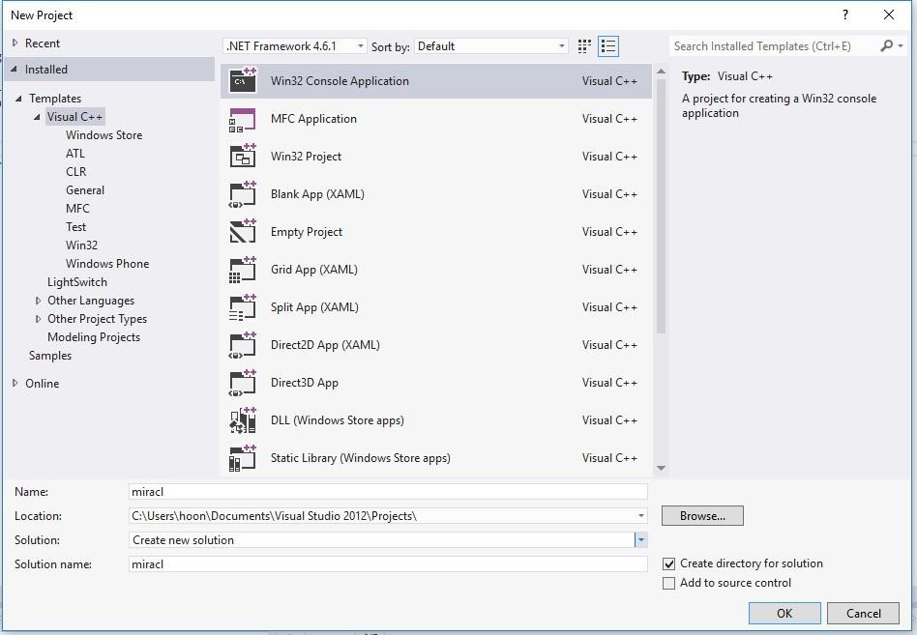

1. Name: miracl. (it is important to name the project as “miracl” because we will be later using miracl key word to include it in other program for cryptographic schemes)
2. Location: “C:\Users\hoon\Documents\VIisual Studio 2012\Projects\”. Note “hoon” in this case is user name, like if the user name is “xxx” location will be

“C:\Users\xxx\Documents\Visual Studio 2012\Projects\”

1. Solution name: miracl
2. Click OK
3. Click Application settings, you can see the application settings in left panel, in the figure below

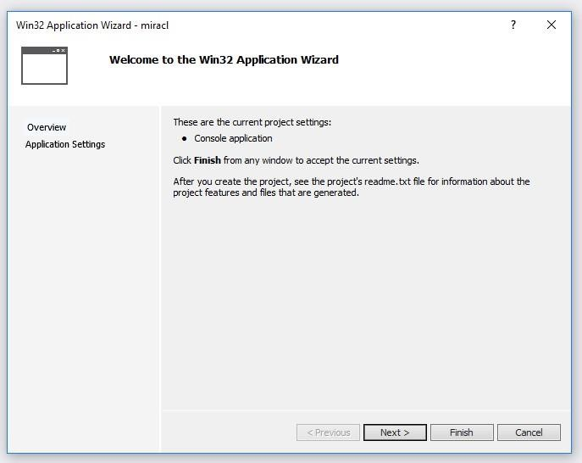

1. Click on Static library.

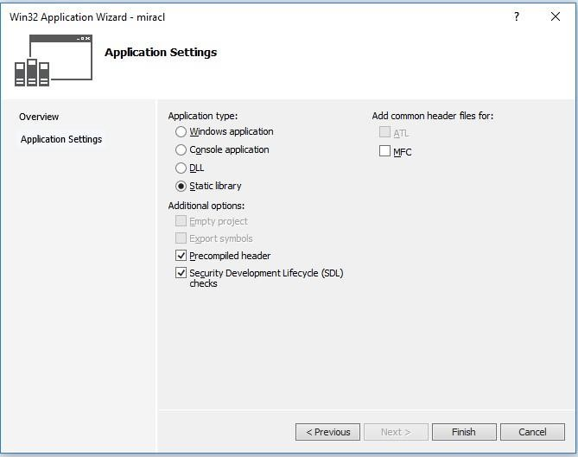

1. Disable precompiled header

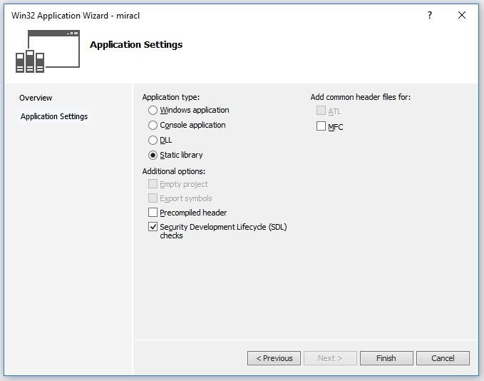

1. Click on Finish
2. Click on Project (in this case it is “miracl” in the left panel as shown in figure), and got to Add→Existing Item.

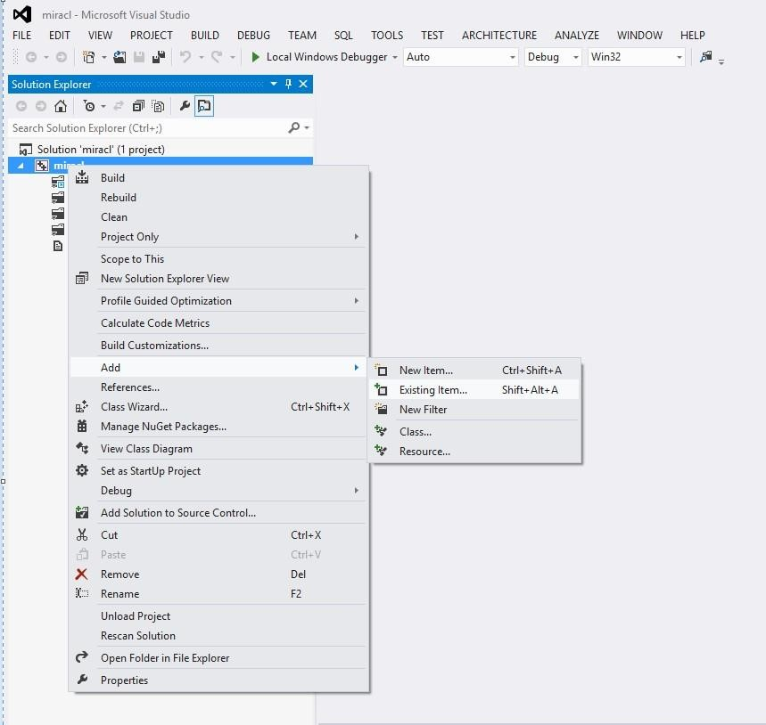

1. Add miracl.h and mirdef.h from wherever you have unzipped the miracl distribution

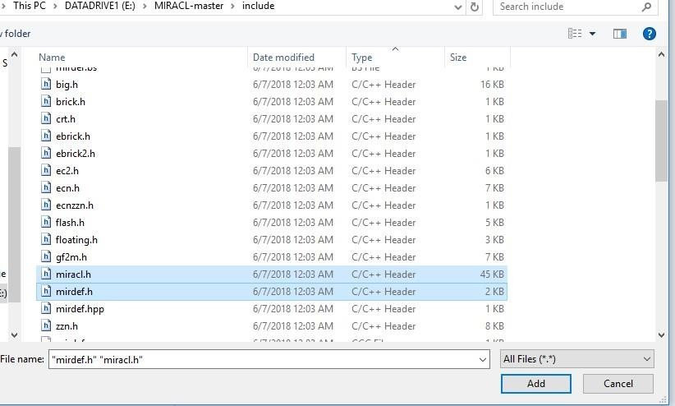

1. Click on Project (in this case it is “miracl” in the left panel as shown in figure), and go to Add→Existing Item.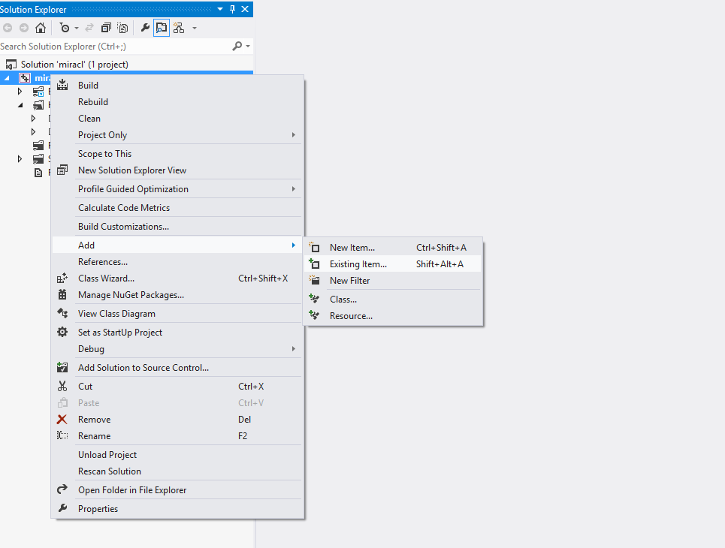

13. Add the following miracl source files from the miracl distribution to the project

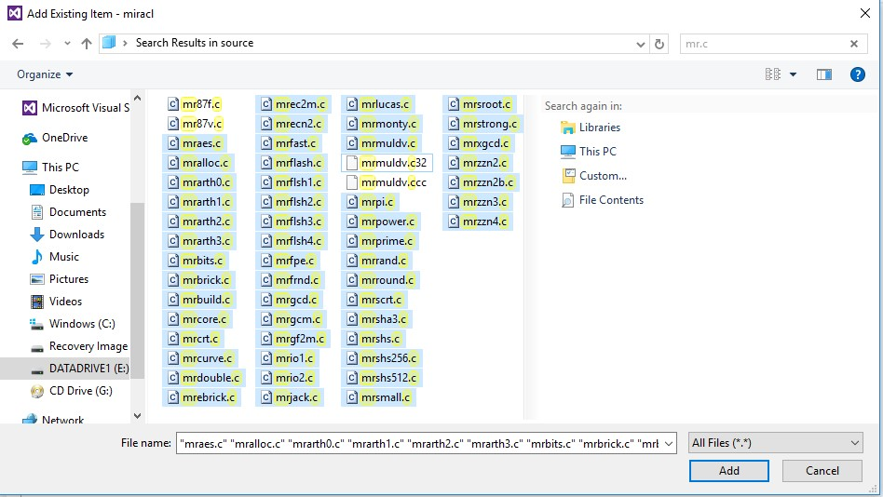

* mraes.c
* mralloc.c
* mrarth0.c
* mrarth1.c

• mrarth2.c

* mrarth3.c
* mrbits.c
* mrbrick.c
* mrbuild.c
* mrcore.c
* mrcrt.c
* mrcurve.c
* mrdouble.c
* mrebrick.c
* mrec2m.c
* mrgf2m.c
* mrfast.c
* mrflash.c
* mrflsh1.c
* mrflsh2.c
* mrflsh3.c
* mrflsh4.c
* mrfrnd.c
* mrgcd.c
* mrgcm.c
* mrio1.c
* mrio2.c
* mrjack.c
* mrlucas.c
* mrmonty.c
* mrmuldv.c
* mrpi.c
* mrpower.c
* mrprime.c
* mrrand.c
* mrround.c
* mrscrt.c
* mrshs.c
* mrshs256.c
* mrshs512.c
* mrsmall.c
* mrsroot.c
* mrstrong.c
* mrxgcd.c 
* mrecn2.c
* mrzzn2b.c
* mrzzn3.c
* mrzzn2.c
* mrzzn4.c

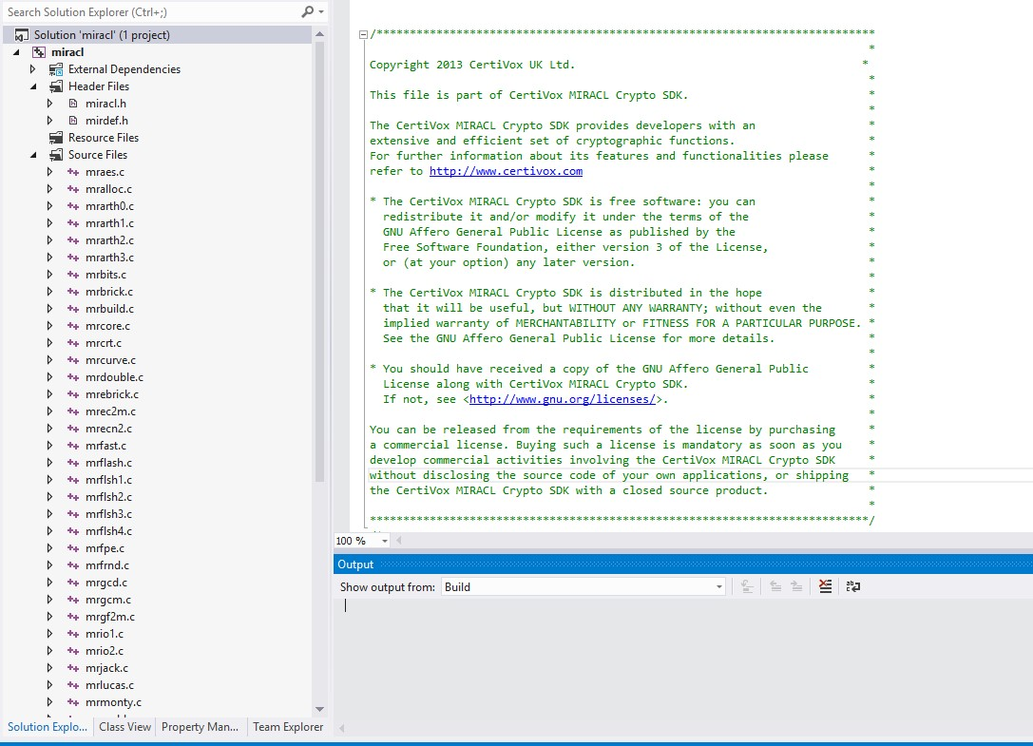

14. Right click on the miracl in the left panel and go to the properties→C/C++→General →Additional Include directories. Then select the include folder from miracle distribution as show in below figure.

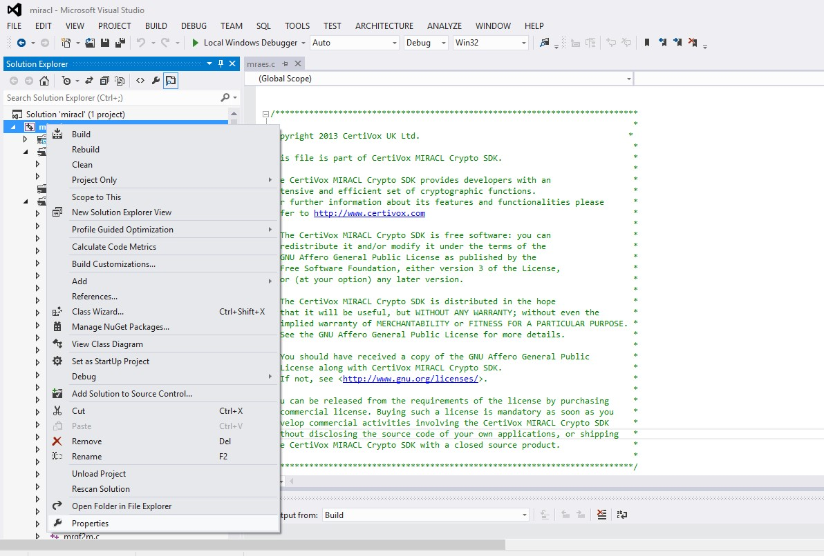

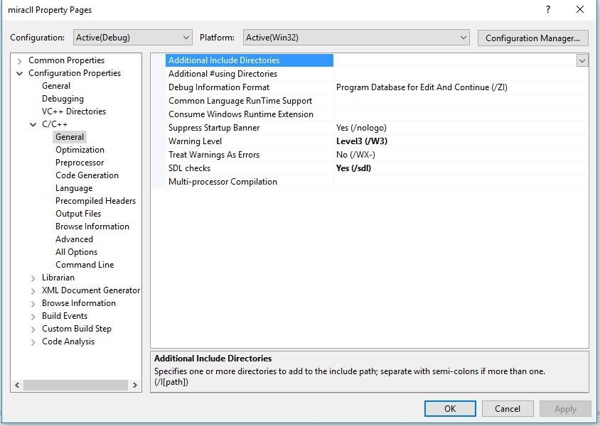

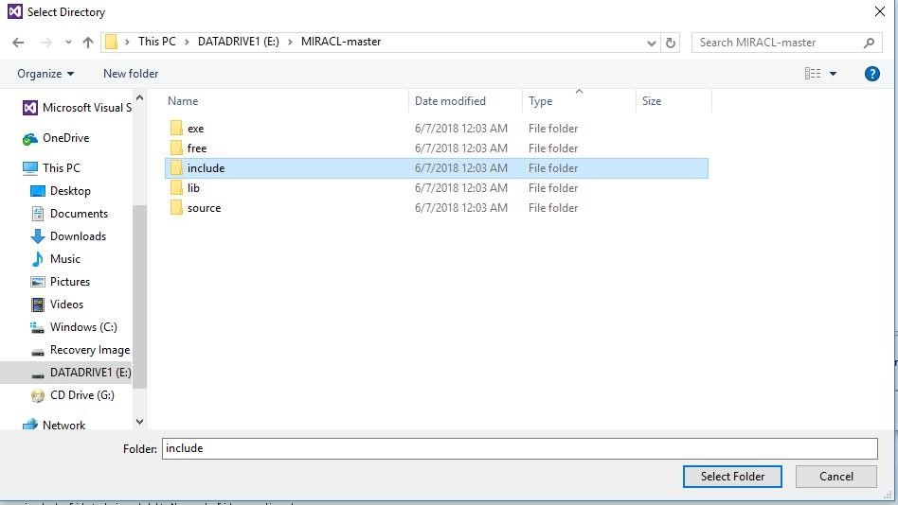

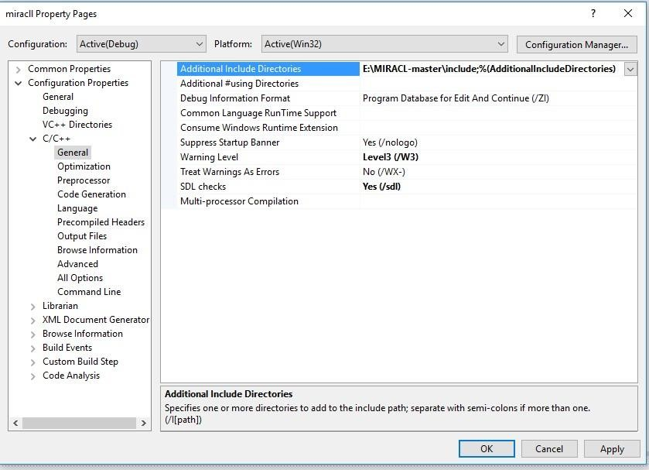

* Note: if you will not include the “include” directory of miracl distribution the compiler cannot build the program, prompting the following errors.

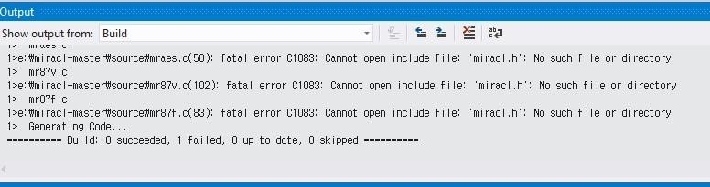

To avoid the error in show in above figure you must include the “include directory of miracl distribution”.

* Then Click on Build miracl. The library is created in directory

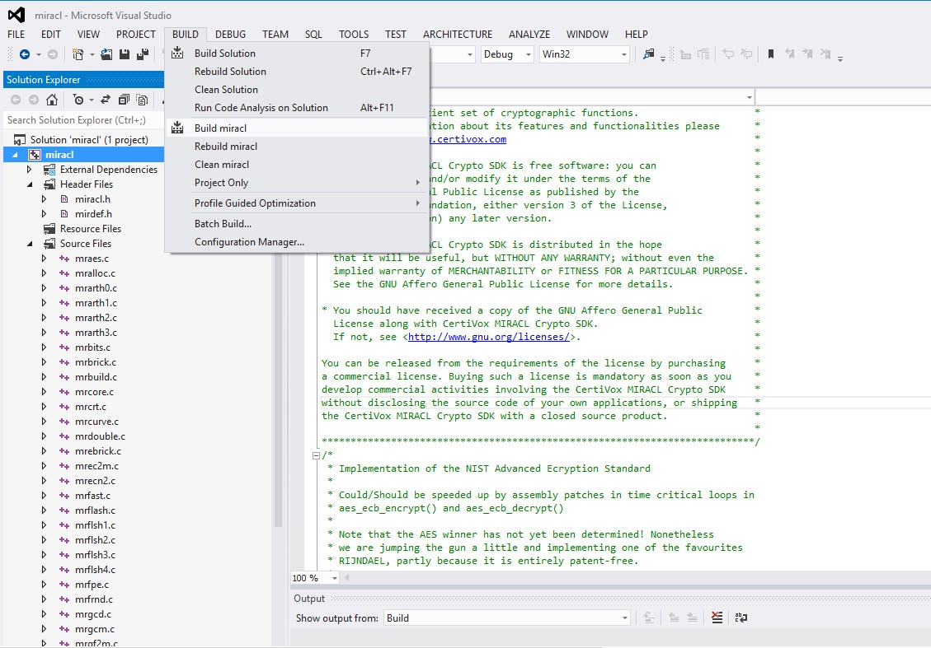

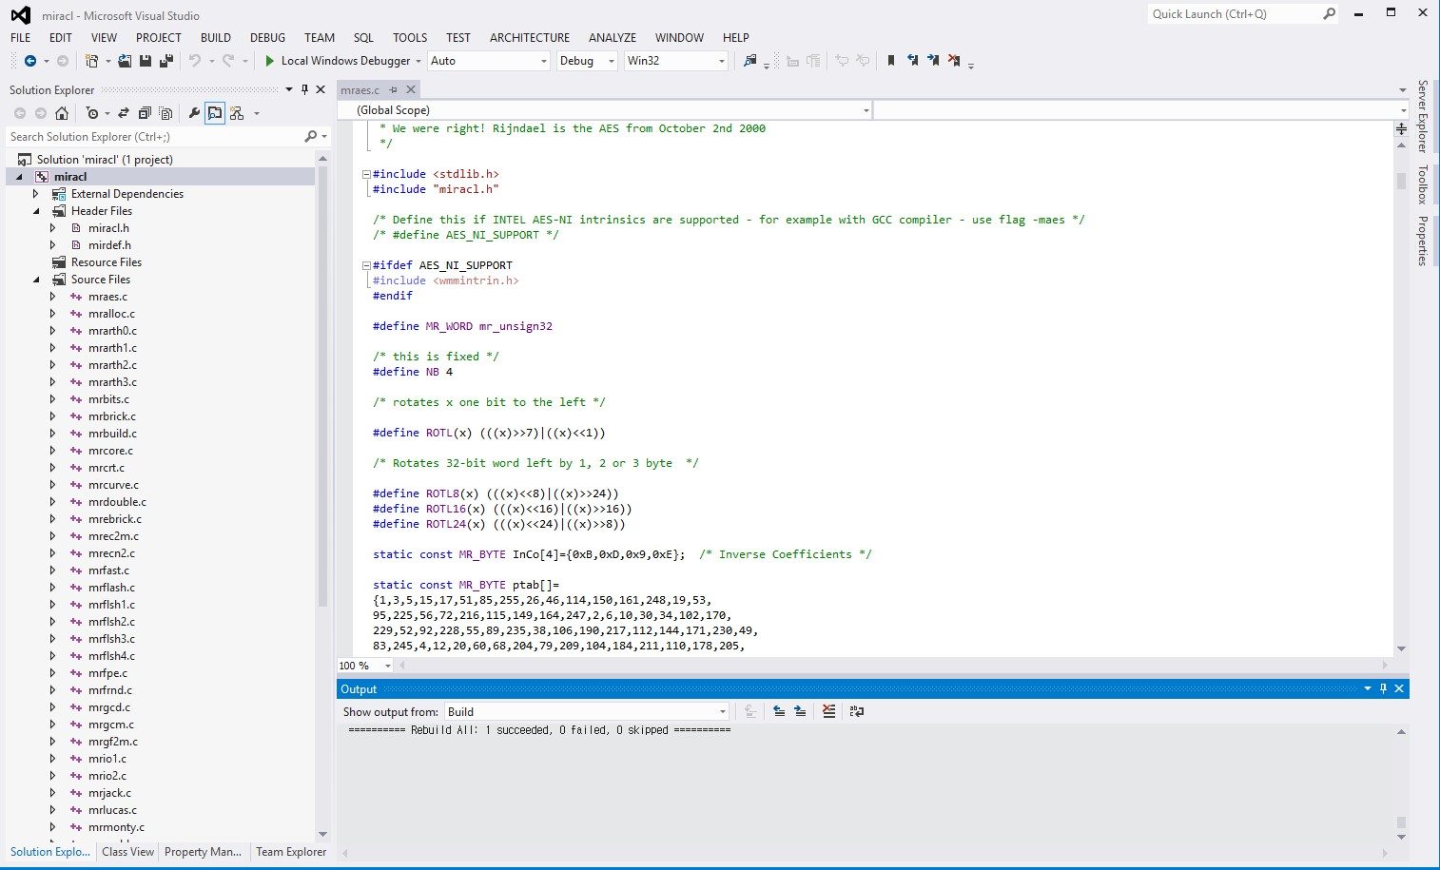

* Got to the location where you built the project. For example in this case: In the location

“C:\Users\hoon\Documents\Visual Studio 2012\Projects\miracl\debug\miracl.lib” you will find the “maricl.lib” file. Note “hoon” in this case is user name, like if the user name is “xxx” then you can find the file in “C:\Users\xxx\Documents\Visual Studio 2012\Projects\miracl\debug\miracl.lib”

